Lake House Bar& Grill with Real Estate
FOR SALE
“Owner Offers 1st Mortgage Financing!”

Located on RT. 34 in Seymour, CT, and known as Lake House Bar & Grill, this is a great opportunity for a hands-on operator to take advantage of all this property has to offer. The restaurant & bar is approximately 3,600 S/F with a total seating capacity of 180 seats in the dining rooms, bar and lounge, and on the outdoor waterside deck with spectacular views of The Housatonic River, plus 4 private boat slips directly below the deck, with rights to expand. The business is currently grossing approximately $140,000 monthly, which is below its true potential, as the current owner is a hands-off owner/investor, and at the mercy of managers running the business. Big upside opportunity on this one, especially if you cater to waterfront private events during the off season, and a must see. Please visit the restaurant’s website at:

lakehouseseymour.com‎

Asking: $1,300,000

Includes the business and the real estate, and all serious offers will be considered. Seller will hold a 10 year 1st mortgage with 40% down, at an interest rate of 4%

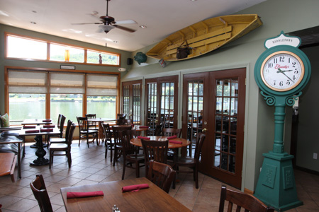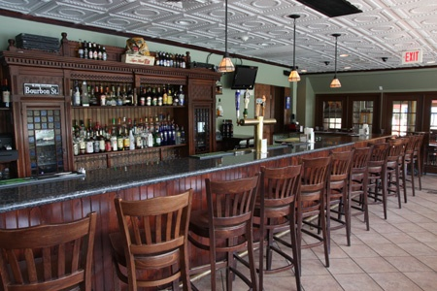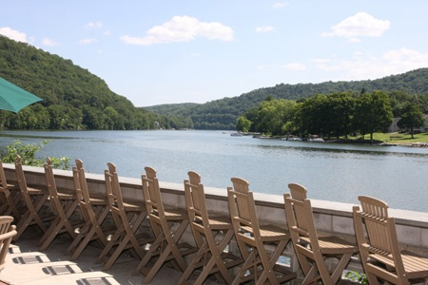

For Additional Information Contact Exclusive Broker:

Steve Matsis,
senior managing director
(203) 496-6274

PYRAMID RESTAURANT GROUP
“Connecticut’s 1st Choice in Restaurant Brokerage”

Restaurant Businesses for Sale
Restaurants with Real Estate for Sale
Restaurant Locations for Lease
Closed/Distressed Restaurant Asset Sales

